Thomas Telford Multi Academy Trust

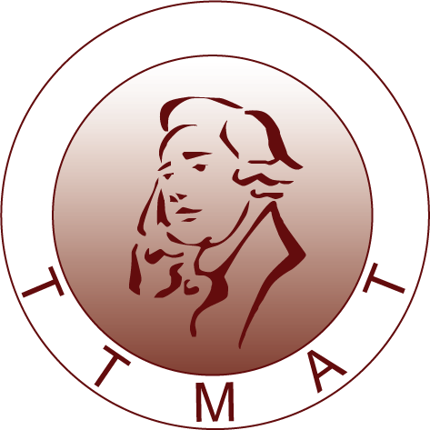

PSHE Policy
Redhill Primary Academy and Thomas Telford Primary Free School
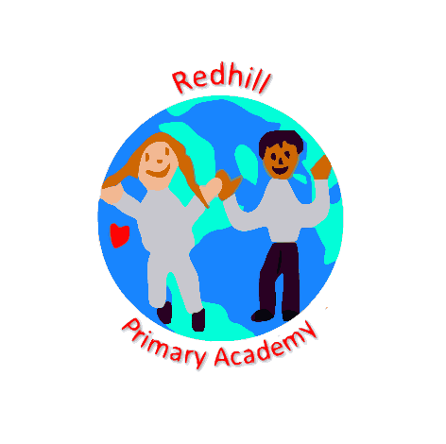 | 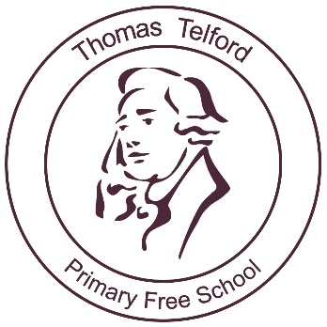
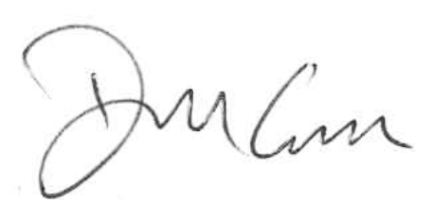
Signed

Mr Dara Carroll
Chair of Governors
September 2025

Contents
Our Vision 2
Aims and Principles 2
Our PSHCE Offer 3
The Taught Curriculum 4
Enrichment Weeks 5
A Valued Me 5
Further 5
Safeguarding 6
Curriculum Leadership and Management 6
Resources 7
Monitoring and Assessment 7
The Role of the Equality Act 8
Review 8

Our Vision

“Children can benefit enormously from high-quality Personal, Social, Health and Economic Education. Good PSHE supports individual young people to make safe and informed choices.”

At our schools, we pride ourselves on developing not only children’s academic knowledge, but the child as a whole. We believe that PSHCE is a subject which should develop the knowledge, skills and attributes children need to allow them to lead healthy, safe lifestyles within Modern Britain. It should prepare them for the future and give them the confidence they need to succeed in their life. In its simplest form, it should help to develop well-rounded individuals.
Because of this, it is vital to us that this PSHCE offer is fully embedded within the ethos of our school. As well as our explicit taught lessons, our offer covers areas including, but not limited to, British Values, Protected Characteristics, SMSC, Mental Health and Wellbeing, Relationships Education, Collective Worship, LGBTQ+ awareness and e-safety.

Aims and Principles
Through the breadth of our PSHCE offer, we aim to successfully achieve our aims:
- To teach children about themselves, others and the world around them in order to inspire and develop a sense of wonder.
- To develop a mutual respect of and understanding for those around them and their differences – encouraging them to appreciate and celebrate diversity both within school and in the community.
- To encourage the ability to reflect on and learn from their own experiences in order to help them grow as individuals.
- To develop their moral compass – giving them the opportunity to recognise the difference between right and wrong and understand the consequences of their actions – allowing them to develop an understanding of the impact their actions have on both themselves and the wider world.
- To refine their skills in co-operation and conflict resolution.
- To raise children’s awareness of the wider world and to encourage them to take an active and responsible role in their learning.
- To develop the skills in the children that allow them to be happy, healthy, capable and upstanding citizens within society through the school’s values: respect, friendship, responsibility, empathy, honesty, independence.
- To develop the children’s understanding of the British Values (democracy, rule of law, tolerance, individual liberty, mutual respect) to allow them to live successfully as an adult in Modern Britain.
- To ensure children know mental wellbeing is a normal part of daily life and to promote positive mental health – giving children the knowledge and capability to identify their mental health, take care of themselves and receive the support they need when problems arise.
- To allow children to have a voice and see that they can have an impact and make a change - developing their sense of self-worth and preparing them to contribute to society.
- To encourage children to make informed healthy lifestyle choices.
- To develop a secure understanding of healthy relationships, focusing on family and friendships, both on and offline.
- To provide an open and safe environment where children feel safe to express themselves, ask questions, take part in discussion and develop a strong sense of self-worth – promoting positive emotional and mental wellbeing.

Our PSHCE Offer
We believe that PSHCE Education is central to the educational entitlement of all of our children. Although it will be taught in part through discreet lessons, elements of PSHCE permeate all aspects of school life. During Key Stages 1 and 2, learners gradually build on the skills, attitudes and values, knowledge and understanding they have started to acquire and develop during the Early Years/Foundation Stage. PSHCE education offers learning opportunities and experiences which reflect the increasing independence and physical and social awareness of learners as they move through the primary phase. They learn skills to develop effective relationships, assume greater personal responsibility and keep themselves safe. PSHCE education assists pupils to cope with the changes at puberty, introduces them to a wider world and enables them to make an active contribution to their communities.
Through our PSHCE offer, we aim to cover the following key drivers -
Relationships and Friendships
- To develop and maintain a variety of healthy relationships, within a range of social/cultural contexts.
- To recognise and manage emotions within a range of relationships.
- To recognise risky or negative relationships including all forms of bullying and abuse.
- To respond to risky or negative relationships and ask for help.
- To respect equality and diversity in relationships.
- To understand the impact of love and loss.

Health and Wellbeing
- What is meant by a healthy lifestyle?
- To maintain physical, mental and emotional health and wellbeing.
- To manage risks to physical and emotional health and wellbeing ways of keeping physically and emotionally safe.
- About managing change, including puberty, transition and loss.
- To make informed choices about health and wellbeing and to recognise sources of help with this.
- To identify different influences on health and wellbeing.
- To manage the negative impact of media and celebrity culture to help maintain a positive body image.

Personal Safety
- To understand the importance of being safe.
- To recognise the need for safety online and understand acceptable ways to behave online.
- To identify trusted adults and recognise who I can ask for help.
- To understand the importance of consent.
- To develop a basic understanding of emergency aid.
- To recognise the need for pedestrian safety.

Equality and Diversity
- To have an awareness of the protected characteristics.
- To develop an understanding about different groups and communities.
- To respect equality and to be a productive member of a diverse community.
- To recognise stereotypes and how they can impact the way we view other people.
- To understand and respect different family types.
- To understand types of discrimination and how differences can lead to conflict.

Aspirations (including economic wellbeing)
- To recognise the importance of setting and achieving goals.
- To know the importance of perseverance when faced with challenge or failure.
- To understand where money comes from, keeping it safe and the importance of managing it effectively.
- To know how and why money plays an important part in people’s lives.
- To develop a basic understanding of enterprise.
- To know a wide range of careers, understand what these careers might entail and that different jobs will lead to different incomes.

Responsibility
- To understand their responsibility for their own learning and consider how they learn best.
- To develop a secure understanding of right and wrong and of fairness.
- To know their rights and responsibilities as a child and as members of families, other groups and ultimately as citizens.
- To understand their role in respecting and protecting the environment.
- To understand consequences and the rule of law and how this will impact them in life.
- To develop on understanding of democracy and how it works.
- To make a positive contribution to society.
- To have an awareness of global issues and the impact they have on the world.

Independence
- To know my self-worth and accept who I am.
- To have respect for self and others and the importance of responsible behaviours and actions.
- To recognise peer pressure and the impact of this.
- To understand the importance of being assertive and having the right to say no.
- To understand that everyone will have their own personal opinion and that it is ok to express those opinions in a respectful manner.

The Taught Curriculum

Our taught curriculum is robust, takes place in regular timetabled slots across the whole school and focuses on our key drivers of relationships and friendships, health and wellbeing, personal safety, equality and diversity, aspirations (including economic wellbeing), responsibility and independence. As part of this taught curriculum, all classes from Nursery upwards follow the JIGSAW programme. As the JIGSAW programme is a spiral, progressive programme - topics are repeated throughout school, gradually increasing in depth and complexity, building on the children’s prior knowledge from previous years. Through this, children are given relevant learning experiences to help them navigate their world and to develop positive relationships with themselves and others. JIGSAW has a strong emphasis on mental and emotional well-being of children with sensitive issues being explored and discussed at an age-appropriate level. Despite following the JIGSAW scheme, we encourage all our staff to be reactive and responsive to the needs of the children in their class – adapting lessons where needed, responding to local/national/global events, picking up on incidental learning opportunities and responding to children’s specific questions or misconceptions.
In our schools, we have made the decision to use the Respect Yourself programme for our focused RSE coverage. The Respect Yourself programme has been written by Shropshire Council and was awarded the quality Kitemark standard for good practice by the PSHCE Association. The programme was developed in partnership with several Shropshire Schools, their pupils and parents and is now used by many schools in the local area and beyond. This programme is planned for progression through each year group with a focus on developing a secure understanding of healthy relationships, focusing on family and friendships. To further prepare the children of our schools for life in modern Britain, we also include the No Outsiders programme in our taught curriculum. Through this scheme, we are developing an understanding of the protected characteristics whilst promoting equality and diversity through an ethos of inclusion and tolerance. Alongside this, we use the NSPCC PANTS and ‘Just a Joke’ resources to ensure our Relationships coverage is comprehensive and explicitly covers issues such as consent, sexual harassment and sexting.
In our schools, we place great importance on preparing children for the challenges they may face negotiating the world of technology. Through using the Project Evolve programme (which forms part of the computing and the PSHCE curriculum) – we encourage children to consider the online identity they are creating and about healthy online behaviours and relationships. In addition, we focus in on cyberbullying – looking at how bullying might take place online, discussing child on child abuse, knowing where to go for help and knowing how to report and block abusive users. In year 6, this is further supported by the Just a Joke lessons which focus specifically on sexualised online bullying.

Enrichment Weeks
These weeks, which have a specific focus, are used to give certain aspects of everyday school life a higher profile. In our schools, these weeks include Friendship Week, British Values Week, Aspirations and Careers Week and Healthy Lifestyles Week (which includes promoting positive mental health) amongst others.

A Valued Me
In our schools, we recognise that strong values underpin good behaviour. This has led to the development of our whole school core value system which aims to instil in the children the values which we, as a school, feel they need in order to become healthy, happy, capable and upstanding citizens in society.
Each half term, we will have a different focus for our programme where children will be given the opportunity to demonstrate their understanding of each of the values:
Autumn 1 – Respect
Autumn 2 – Friendship
Spring 1 – Responsibility
Spring 2 – Empathy
Summer 1 – Honesty
Summer 2 – Independence
The implementation of these values will also play a vital role within our school in ensuring that children’s well-being and mental health is at the forefront of all that we do. During the half term, there will be assemblies which directly link to each of our chosen values. The staff will also exploit links within their teaching, where possible, to embed the value throughout the half term and children will be rewarded through our positive behaviour systems if they demonstrate the value during their time at school.

Further PSHCE coverage
There are many other ways in which we promote personal development and prepare children for the future while they are at our schools.
Through our collective worship, children’s PSHCE curriculum is further embedded. This is done through coverage of a variety of topics including our school values, the protected characteristics, online safety, mental health, sustainability and many others. Alongside this, we have celebration assemblies where, as well as celebrating children’s academic achievements, children can receive a certificate for demonstrating one of our school values.
Children are encouraged to contribute to the school community and appreciate that they are given a range of responsibilities through our pupil voice groups and year 6 roles. It is important to us that children feel that their views are listened to and that they have an opportunity to be a part of a pupil group and make an impact in an area they are passionate about. Within all of these groups, children are expected to provide a positive role model to other children in school. Currently, we have many opportunities available to the children: Head Boy/Girl, House Captains, Executive School Council, School Council, S.A.F.E group (pupil safeguarding board), Junior Road Safety Officers, Travel Council, Music Council, Playground friends, Eco-Warriors, Fairtrade and E-safety Committee. As they move through the schools, we also encourage children to take part in a range of practical activities that promote active citizenship such as charity fundraising and assemblies.
Throughout their time at our schools, children will have the opportunity to go on a number of school trips. These include residential trips in year 2, 4 and 6 which encourage children to develop their teamwork, independence and resilience. Children also visit different places of worship – developing their understanding of the fundamental British Values and respect for the protected characteristics.
In our schools, we have worked hard to create an after-school club timetable which will appeal to a wide range of children and encourages children to pursue a plethora of different hobbies. Alongside sports-based clubs, such as hockey, tennis, football, dance and gymnastics, the children also have the opportunity to attend clubs in art, French, creative writing, board games, cooking and bushcraft, to name but a few. Within school, there are also a range of lessons available to allow children to learn a musical instrument.

Safeguarding
On occasion, children may discuss issues which are not appropriate for discussion in a whole class setting. These will be noted by the class teacher and children will be given the opportunity to discuss these at another time with an appropriate adult. If a child shares information which the class teacher deems to be a safeguarding risk, they will refer this to one of the designated safeguarding leads within school.

Curriculum Leadership and Management
It is the responsibility of the PSHCE co-ordinator alongside the head teacher and deputy head teacher to ensure the consistent and complete PSHCE coverage within the schools. It is the responsibility of the head teacher and governing body to ensure that statutory requirements are being met.
The PSHCE co-ordinator is responsible for
- developing a PSHCE curriculum which has a clear progression of knowledge, understanding and expectations throughout the whole school
- consistency in coverage both within and across year groups and key stages
- age appropriate content
- leading teaching and learning in PSHCE
- providing up to date advice and support for colleagues
- maintaining an in-depth knowledge of the subject area and keep up to date with the latest developments
- delivery of appropriate up to date CPD to all teaching staff through staff meeting sessions
- monitoring and evaluating teaching and learning across school
- supporting other staff members with their curriculum provision and planning
- management of resources

Resources
Within our schools we have several resources that teachers can make use of to support their teaching of PSHCE. Each year group has a hard copy of the Jigsaw and Respect Yourself programmes as well as computer-based copies. The schools have also obtained copies of the picture books and resources required to support the delivery of these programmes.
Each year group also has a PSHCE based book box – these provide a number of picture books for the teachers to use to support and discuss elements of PSHCE in further detail. This includes aspects such as different families, diversity, emotional intelligence, mindfulness.
A variety of other resources are available. These include children’s reference books, teachers’ resources, books, big books, CD ROMs, audio/visual materials.
The co-ordinator is responsible for maintaining resources, monitoring their use and organising storage. Resource purchasing is in accordance with normal procedures and is based upon the budget. The amount of this budget reflects the degree of priority given in the School Development Plan.

Monitoring and Assessment
As a result of the spiral curriculum, we should see children’s substantive and disciplinary knowledge developing and deepening throughout their time at our schools. This should be clearly evident during pupil voice groups and through book looks carried out throughout the year. The impact of the PSHCE taught in schools will also be seen in the way the children conduct themselves around school, the conversations they have, the way they demonstrate our school values and their understanding and respect of the Protected Characteristics and the British Values. Much of the impact of the curriculum we teach may not be seen whilst the children are at our schools and will be seen well into the future when they encounter the situations and scenarios that we prepare them for. Where children are identified as struggling with certain areas of the curriculum or are not consistently demonstrating a secure understanding of the substantive and disciplinary knowledge for their age, they will be further supported (with content adapted where needed and misconceptions responded to) in order to close the gap and see accelerated progress.
Evidence of learning across all areas of PSHCE will be presented in class books to give a snapshot of the learning taking place. This will include evidence of taught lessons, enrichment weeks, visiting speakers and incidental learning.
All staff have access to the skills document and unit overviews to ensure clear progression in PSHCE across key stages – these show explicitly which area of the PSHCE curriculum each lesson links to.
Monitoring is carried out by the headteacher, deputy headteacher, the PSHCE co-ordinator and the safeguarding co-ordinator in several ways:
- regular scrutinies of the work being presented in pupils’ books
- informal teaching observations across all the key stages when appropriate
- supported planning
- ongoing informal discussion with teachers
- pupil voice groups with children

The Role of the Equality Act
Under the provisions of the Equality Act 2010, schools must not unlawfully discriminate against any pupils based on their age, sex, sexual orientation, race, disability, religion or belief (the protected characteristics). Our schools will ensure that, where there may be a disadvantage based on one of these protected characteristics, reasonable adjustments will be made. In addition, where there are pupils with special educational needs and disabilities – teaching will be differentiated and personalised to ensure it is accessible to all and taught at an appropriate level. Where specific content of the curriculum may not be appropriate due to religious beliefs, parents have a right to withdraw children from those lessons.

Review
This policy will be reviewed bi-annually and will be reviewed in Spring 2026.

